Sudeepto Roy

1546008

ROGER CHARLIE

Logging into the page got a website asking for username, password and a hint code word.

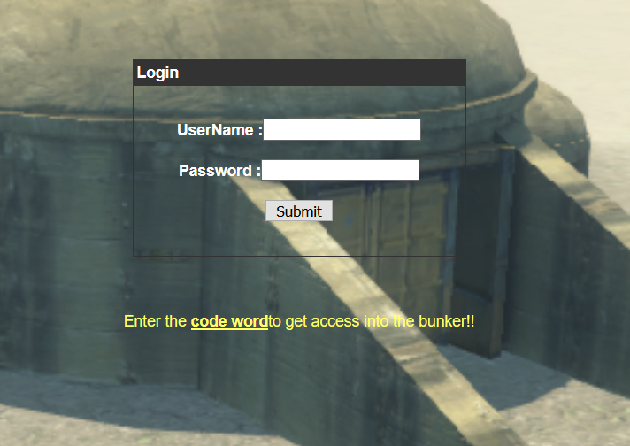

Clicking code word , we get an audio file .

Going online , found a morse decoder .

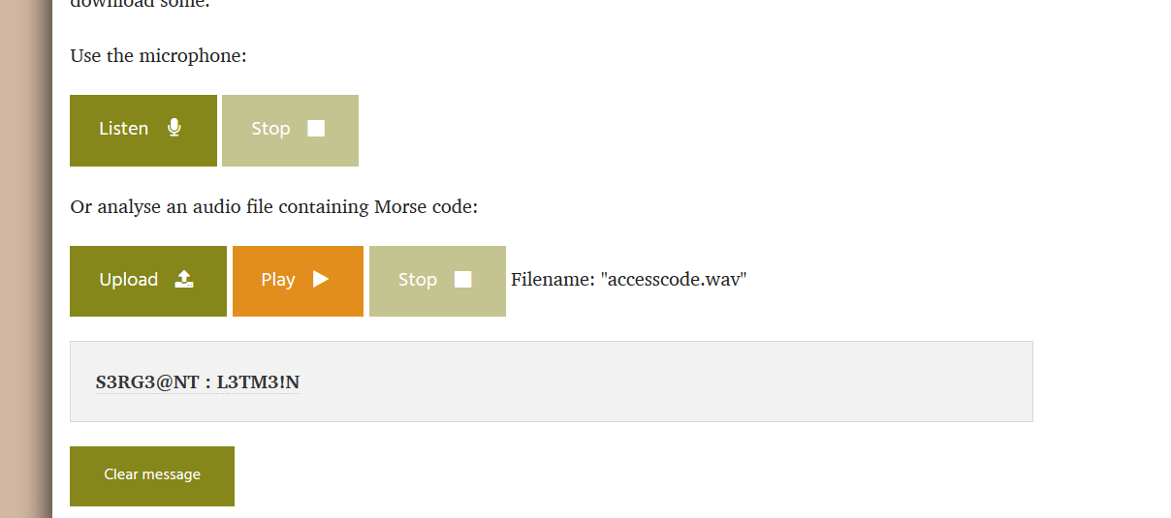

We got the username and password .

On entering the username and password in the login form , we got the FLAG !!!!!!!!!!!!!

